<https://www.youtube.com/shorts/WDpc1olT2n0>

<https://www.youtube.com/shorts/nRfedP8BC8Y>

**https://www.youtube.com/shorts/oivxmsbRi9w**

############## Frequently Asked Interview question ################

|  |  |  |  |  |
| --- | --- | --- | --- | --- |
| **emp.id** | **Name** | **dep.id** | **salary** | **manager_id** |
|  |  |  |  |  |

* 1. How to find duplicate value in table

Ans: select emp.id,count(1) from Employee

group by emp.id

having count(1) > 1;

* 1. How to delete the duplicates from the table?

Ans. Here we can use CTE(common table expression) its like temporary table used to simplify the query .

To find duplicate values we will use Row_num() function.

Here 1st write row number query >>>> CTE>>>> Upper query:

Select * from Employee

With CTE AS

(Select *,row_number() over(partition by emp_id order by emp.id) as Rw_Num

From Employee)

Delete from CTE where Rw_Num > 1;

* 1. Difference between Union & Union All

Ans. Union All will give all values uncluding duplicates Whereas Union will give only unique values.

* 1. Difference between Rank,Dense rank & Row number:

Ans:

|  |  |  |  |
| --- | --- | --- | --- |
| **emp.id** | **Name** | **dep.id** | **salary** |
| 1 | Ank | 100 | 10000 |
| 2 | Moh | 100 | 15000 |
| 3 | Raj | 100 | 10000 |
| 4 | Tej | 100 | 5000 |
| 5 | Ketan | 200 | 12000 |
| 6 | Sneha | 200 | 12000 |
| 7 | siddhi | 200 | 9000 |
| 8 | Keshar | 200 | 5000 |

Select *,

Rank() OVER (order by salary desc) as Rank,

Dense_Rank() OVER(order by salary desc ) as Dense_Rank,

Row_Number() OVER(order by salary desc ) as Row_Number

FROM Employee e;

So result is ranked overall by salary desc:

|  |  |  |  |  |  |  |
| --- | --- | --- | --- | --- | --- | --- |
| **emp.id** | **Name** | **dep.id** | **salary** | **Rank** | **Dense_Rank** | **Row_Number** |
| 1 | Ank | 100 | 15000 | **1** | 1 | 1 |
| 2 | Moh | 200 | 12000 | 2 | 1 | 2 |
| 3 | Raj | 200 | 12000 | 2 | 1 | 3 |
| 4 | Tej | 100 | 10000 | 4 | 3 | 4 |
| 5 | Ketan | 100 | 10000 | 4 | 3 | 5 |
| 6 | Sneha | 200 | 9000 | 6 | 4 | 6 |
| 7 | siddhi | 200 | 5000 | 7 | 5 | 7 |
| 8 | Keshar | 100 | 5000 | 7 | 5 | 8 |

# If we want Ranks basis on each department salary:

Select *,

RANK() OVER (PARTITION BY Dep_Id ORDER BY salary desc) as Rank,

DENSE_RANK() OVER(PARTITION BY Dep_Id ORDER BY salary desc ) as Dense_Rank,

ROW_NUMBER() OVER(PARTITION BY Dep_Id ORDER BY salary desc ) as Row_Number

FROM Employee e;

Result:

|  |  |  |  |  |  |  |
| --- | --- | --- | --- | --- | --- | --- |
| **emp.id** | **Name** | **dep.id** | **salary** | **Rank** | **Dense_Rank** | **Row_Number** |
| 1 | Ank | 100 | 15000 | **1** | 1 | 1 |
| 2 | Moh | 100 | 10000 | 2 | 2 | 2 |
| 3 | Raj | 100 | 10000 | 2 | 2 | 3 |
| 4 | Tej | 100 | 5000 | 4 | 3 | 4 |
| 5 | Ketan | 200 | 12000 | 1 | 1 | 5 |
| 6 | Sneha | 200 | 12000 | 1 | 1 | 6 |
| 7 | siddhi | 200 | 9000 | 3 | 2 | 7 |
| 8 | Keshar | 200 | 5000 | 4 | 3 | 8 |

**Q. 5. Find department wise highest salary :**

We will use Rank function:

Select * from

(Select *,

Rank() OVER(PARTITION BY Dep_Id ORDER BY Salary desc) AS Rnk

FROM Employee) AS A

Where A.Rnk = 1;

1. **Find the employee which are not in dep. Table:**

Employee:

|  |  |  |  |
| --- | --- | --- | --- |
| **emp.id** | **Name** | **dep.id** | **salary** |
| 1 | Ank | 100 | 10000 |
| 2 | Moh | 100 | 15000 |
| 3 | Raj | 100 | 10000 |
| 4 | Tej | 100 | 5000 |
| 5 | Ketan | 200 | 12000 |
| 6 | Sneha | 200 | 12000 |
| 7 | siddhi | 200 | 9000 |
| 8 | Keshar | 200 | 5000 |

Department Table:

|  |  |
| --- | --- |
| **Dep.id** | **Dep_Names** |
| 100 | Analytics |
| 300 | IT |

1. Select * from Employee where Dep.id NOT IN In (select Dep.id from Department) ;
2. Select E.*,D.* from Employee E

Left Join Dapartment D

ON E.Dep_Id=D.Dep_Id where E.Dep_Id = D.Dep_id

Where Dep_Name is NULL;

* 1. Find 2nd Highest salary in each department;

Ans: select * from

(select Dense_Rank() OVER (Partition by Dep_Id ORDER BY Salary desc) AS D_Rank From Employee

) A

where A.D_Rank= 2;

* 1. Find all Transactions done by ‘SHILPA’

|  |  |  |  |
| --- | --- | --- | --- |
| **Customer_Name** | **Order date** | **Order amount** | **Gender** |
| SHILPA | 05-08-2024 | 2 | F |
| Raj | 12-08-2024 | 4 | M |
| Mohan | 05-07-2024 | 4 | M |
| shilpa | 05-06-2024 | 1 | F |

Ans: Select * from Order where Upper(Customer_Name) = ‘SHILPA’

* 1. Update query to swap gender

Ans: We cant use simply Update statement where Gender = Male make it female likewise. So use below way to tackle this issue:

Update Order SET Gender =

Case When Gender = ‘F’ Then ‘M’

When Gender = ‘M’ Then ‘F’

End;

* 1. What is order of Execution in SQL?

Ans: From > Where > Group BY > Having > Select > Order BY > Limit

* 1. Find Monthly sales & sort it by Desc order.

|  |  |
| --- | --- |
| **Order_Date** | **Sales** |
| 2024-01-01 | 10 |
| 2024-01-15 | 15 |
| 2024-02-03 | 20 |
| 2024-02-04 | 30 |
| 2024-05-05 | 40 |
| 2024-03-05 | 50 |
| 2024-03-10 | 60 |

Ans:

Select Extract(Year from Order_Date) as Year,

to_char(Order_date,’Mon’) AS Months,

Sum(Sales) as Total_Sales

From Products

Group by 1,2

Order by 3;

Output:

|  |  |  |
| --- | --- | --- |
| **Year** | **Months** | **Total_Sales** |
| 2024 | 1 | 25 |
| 2024 | 2 | 50 |
| 2024 | 3 | 110 |
| 2024 | 5 | 40 |

* 1. Find the candidate suitable for Data science job having skills: Python,SQL,PowerBi.

Write a query to list the candidates possess required skills as above & sort it by Candidate id asc.:

|  |  |
| --- | --- |
| **Cand_Id** | **Skills** |
| 101 | Power BI |
| 101 | Python |
| 101 | SQL |
| 102 | SQL |
| 108 | Python |
| 108 | SQL |
| 108 | Power BI |
| 104 | SQL |

Ans: Select Cand_Id, Count(skills)

from DS

Where Skills IN (‘Python’,’SQL’,’PowerBI’)

Group by Cand_Id

Having Count(Skills) = 3

Order by Cand_Id asc;

* 1. You have table Named A with input is n= 1,2,3,4,5 as input. Write query to get output as
     1. 1 times , 2- 2 times ,3- 3 times like wise upto 5

Ans:

Create TABLE Numbers (n int);

Insert into Numbers

Values (1),(2),(3),(4),(5);

Solution to Que: 1) With CTE AS

(

Select n, 1 as num_counter from numbers

UNION ALL

Select n, num_counter+1 as num_counter from CTE

Where num_counter+1 <= n

)

Select n from CTE

Order by n;

* 1. You are provided with a table named Products containing information about various products, including their names and prices. Write a SQL query to count number of products in each category based on its price into three categories below. Display the output in descending order of no of products.  
        
     1- "Low Price" for products with a price less than 100  
     2- "Medium Price" for products with a price between 100 and 500 (inclusive)  
     3- "High Price" for products with a price greater than 500.  
     Tables: Products

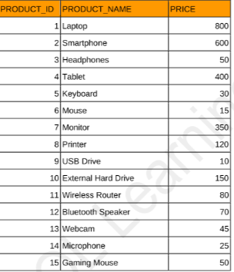

Ans: Using CTE as:

With CTE AS (

Select * ,Case

WHEN price < 100 THEN 'Low Price'  
 WHEN price between 100 AND 500 THEN 'Medium Price'  
 ELSE 'High Price'

END As Category

FROM Products

)

Select Category,Count(*) as Num_of_Products from CTE

Group by category

Order by Num_of_Products;

**Que . 1 We have table data User with columns: user id | Transaction_Date | Trans_Id .**

**How to check May customers,June customers ,Ratio using SQL?**

WITH May_Customers AS (

SELECT DISTINCT user_id

FROM User

WHERE EXTRACT(MONTH FROM Transaction_Date) = 5

AND EXTRACT(YEAR FROM Transaction_Date) = 2024 -- Adjust the year as needed

),

June_Customers AS (

SELECT DISTINCT user_id

FROM User

WHERE EXTRACT(MONTH FROM Transaction_Date) = 6

AND EXTRACT(YEAR FROM Transaction_Date) = 2024 -- Adjust the year as needed

)

SELECT COUNT(DISTINCT May_Customers.user_id) AS May_Customers_Count,

COUNT(DISTINCT June_Customers.user_id) AS June_Customers_Count,

(COUNT(DISTINCT June_Customers.user_id) * 1.0 / COUNT(DISTINCT May_Customers.user_id)) AS Customer_Ratio

FROM May_Customers

LEFT JOIN June_Customers

ON May_Customers.user_id = June_Customers.user_id;

**OR**

WITH May AS (

SELECT COUNT(DISTINCT user_id) AS May_Customers

FROM User

WHERE EXTRACT(MONTH FROM Transaction_Date) = 5

AND EXTRACT(YEAR FROM Transaction_Date) = 2024

), June AS (

SELECT COUNT(DISTINCT user_id) AS June_Customers

FROM User

WHERE EXTRACT(MONTH FROM Transaction_Date) = 6

AND EXTRACT(YEAR FROM Transaction_Date) = 2024

)

SELECT June.June_Customers,

May.May_Customers,

(June.June_Customers * 1.0 / May.May_Customers) AS Customer_Ratio

FROM June, May;

Que. What is data analytics?

Ans: Data Analytics is the process of examining and interpreting data to extract meaningful insights.

* It involves collecting, cleaning, and transforming data
* Applying statistical and machine learning techniques to analyze data
* Visualizing and communicating insights to stakeholders
* Examples include predicting customer behavior, optimizing business processes, and identifying trends in healthcare data

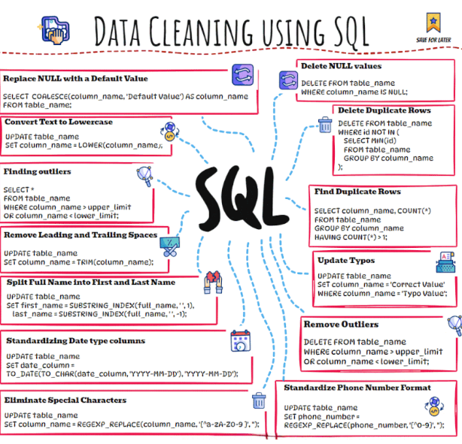

* 1. Scenario based questions:

how to analyze the root cause analysis to check the reduced transactions in PhonePay?

Ans: We will consider below factors:

**Data Collection:**

ather relevant data to analyze the potential causes of the problem.

* Transaction Data: Historical data of transactions, including trends before and after the decline.
* Customer Feedback: Surveys, support tickets, app store reviews, and social media posts that provide insights into customer pain points.
* Technical Metrics: App performance metrics, including transaction success rate, app crashes, latency issues, and downtime.
* Competitor Analysis: Compare your app’s features, pricing, and promotions with competitors like Google Pay, Paytm, etc.
* External Factors: Consider economic downturns, regulatory changes, and shifts in market behavior.

**Identify Potential Causes:**

1) User Experience Issues:

* App Crashes/Performance: Slow or buggy app experience can deter users from completing transactions.
* Interface Changes: Recent UI/UX changes might have confused or alienated users.
* Complex Navigation: Increased steps in transaction completion might discourage users.

2) Technical Glitches:

* Downtime or Service Outages: If the platform experienced outages, users may have switched to competitors.
* Transaction Failures: Frequent payment failures due to server or network issues could reduce trust.

3) External Competition:

* Competitor Promotions: Competitors might be offering cashback or discounts that pull users away.
* User Shifts: Users may shift to alternative payment options like Google Pay or UPI.

4) Marketing and Promotions:

* Reduction in Offers: If previous offers or discounts expired, users may have decreased their transaction frequency.
* Ad Spend: Less advertising or poor targeting may have led to reduced customer acquisition.

5) Demographic or Behavioral Shifts:

* Economic Factors: Unemployment, inflation, or other economic issues could affect user spending.
* User Segments: Certain age groups or regions may have shown a higher drop in transactions.

**Step 4: Analyze the Data**

Use both qualitative and quantitative methods to validate the causes:

* **Trend Analysis:** Compare transaction volumes across different times, dates, regions, and user segments to identify patterns.
* **A/B Testing:** If changes were made to the app or service, analyze how different versions affected user behavior.
* **Correlation Analysis:** Identify whether factors like app performance, offers, or user feedback correlate with the decline in transactions.
* **Customer Segmentation:** Break down the data to see if certain user groups (age, location, frequency) have reduced activity more than others.
  1. Problem: You are given two tables; employees and projects.  
       
     Table 1: employees  
     e_id   e_name    department  
     1    John Doe    Finance  
     2    Jane Smith    IT  
     3    Mike Brown    Finance  
     4    Emma Wilson    IT  
     5    Sarah Davis    Finance
  2. Table 2: projects  
     p_id   e_id    p_name    p_hours  
     101  1    Project A    100  
     102    2   Project B    150  
     103    3    Project A    120  
     104    4    Project C    130  
     105    5    Project B    140  
       
     **Write an SQL query to find the top 2 employees from the Finance department who have worked the most hours across all projects**.

Solution:

select E.e_id ,sum(p_hours) as Total_hours from Employee E

Inner join projects P on E.eid = P.e_id

Where department = ‘Finance’

Group by 2

Order by 2 desc

* 1. employee_id is the primary key for this table.  
     Each row of this table contains the ID of each employee and their respective team.  
     **Write an SQL query to find the team size of each of the employees.**  
       
     Return result table in any order.  
       
     SQL Script:  
     Table: Employee  
       
     +---------------+---------+  
     | Column Name | Type |  
     +---------------+---------+  
     | employee_id | int |  
     | team_id | int |  
     +---------------+---------+

Solution:

Select E.emp_id,A.Team_Size

From Employee E

Join

(Select team_id, count(emp_id) as Team_Size

From Employee

Group by team_id) A

ON E.team_id = A.team_id

OR :

Select emp_id ,

Count(emp_id) over (partition by team_id) as team_size

From Employee

Order by emp_id asc;

(here in above query

**COUNT(emp_id) OVER (PARTITION BY team_id)**:

* This calculates the total number of employees (COUNT(emp_id)) for each team (team_id), which represents the size of that team.
* The PARTITION BY clause ensures that the count is reset for each different team_id, so it only counts employees within the same team.)

|  |  |  |  |  |  |  |
| --- | --- | --- | --- | --- | --- | --- |
|  | | | |  |  |  |
|  | | | |  |  |  |
| **####################### EXL Interview questions:**  1.   |  |  |  |  |  | | --- | --- | --- | --- | --- | | SaleID | ProductID | SaleDate | QuantitySold | salesAmount | | 1 | 1 | 01-01-2023 | 10 | 100 | | 2 | 2 | 01-01-2023 | 5 | 50 | | 3 | 3 | 01-01-2023 | 15 | 20 | | 4 | 1 | 02-01-2023 | 15 | 150 | | 5 | 2 | 02-01-2023 | 7 | 70 | | 6 | 1 | 03-01-2023 | 12 | 120 | | 7 | 2 | 03-01-2023 | 6 | 60 | | 8 | 3 | 03-01-2023 | 16 | 30 | | Find current day sales & Previous day sales in sql with output as below:   |  |  |  | | --- | --- | --- | | ProductId | SaleDate | DifferenceFromPrevious | | 1 | 01-01-2023 |  | | 1 | 02-01-2023 | 50 | | 1 | 03-01-2023 | -30 | | 2 | 01-01-2023 |  | | 2 | 02-01-2023 | 20 | | 2 | 03-01-2023 | -10 | | 3 | 01-01-2023 |  | | 3 | 03-01-2023 | 10 | | | | | | |  |  |  |  |  |  |
|  | |  |  |  |  |  |
|  |  |  |  |  |  |  |
|  | | | | | | |
| Sol:  WITH SalesWithPrevious AS  (  SELECT  s.ProductID,  s.SaleDate,  SUM(s.QuantitySold) AS QuantitySold,  SUM(s.salesAmount) AS salesAmount,  LAG(SUM(s.salesAmount)) OVER (PARTITION BY s.ProductID ORDER BY s.SaleDate) AS previous_salesAmount  FROM SalesData s  GROUP BY s.ProductID, s.SaleDate  )  SELECT ProductID, SaleDate,  (salesAmount - previous_salesAmount) AS difference_from_previous  FROM SalesWithPrevious  WHERE previous_salesAmount IS NOT NULL  ORDER BY SaleDate; |  |  |  |  |  |  |

**########### ICICI Interview Questions ############**

Table A Table B

|  |  |  |  |  |  |
| --- | --- | --- | --- | --- | --- |
| Col1 Name | Col2 Id |  |  | Col3 Name | Col4 Preference |
| a | 1 |  |  | a | apple |
| b | 2 |  |  | a | orange |
| b | 3 |  |  | b | grapes |
| c | 4 |  |  | d | banana |
| c | 5 |  |  | null | litchi |
| c | 6 |  |  | null | guava |
| d | 7 |  |  |  |  |
| null | 8 |  |  |  |  |

q. What is the output of Left join of Table A left join Table B ?

ans:

|  |  |  |  |
| --- | --- | --- | --- |
| **Name_A** | **Id** | **Name_B** | **Preference** |
| a | 1 | a | apple |
| a | 1 | a | orange |
| b | 2 | b | grapes |
| b | 3 | b | grapes |
| c | 4 | NULL | NULL |
| c | 5 | NULL | NULL |
| c | 6 | NULL | NULL |
| d | 7 | d | banana |
| NULL | 8 | NULL | litchi |
| NULL | 8 | NULL | guava |

############################ SQL Practice questions for Interviews ########################################

* + 1. **Explain the difference between INNER JOIN and OUTER JOIN?**

Ans: An **INNER JOIN** returns only the rows where there is a match in both tables.

An **OUTER JOIN** returns all the rows from one (or both) of the tables, even if there is no match. If no match is found, NULL values are returned for columns from the table that doesn't have a corresponding match.

* + 1. **Write a query to fetch the second-highest salary from an employee table?**

Ans:

With SalaryRank AS

( Select *, ROW_NUMBER() OVER (ORDER BY salary DESC) AS rank

From employees )

Select salary AS 2nd_highest_salary

From SalaryRank

Where rank = 2;

* + 1. **How would you find duplicate rows in a table and delete them?**

**Ans:**

Finding Duplicate Rows:

SELECT name, email, phone_number, COUNT(*) AS duplicate_count

FROM employees

GROUP BY name, email, phone_number

HAVING COUNT(*) > 1;

Deleting Duplicate Rows:

WITH CTE AS

( SELECT *, ROW_NUMBER() OVER (PARTITION BY name, email, phone_number ORDER BY id) AS row_num

FROM employees )

DELETE FROM CTE

WHERE row_num > 1;

* + 1. **Describe how you would use GROUP BY and HAVING to filter grouped data.**

Ans: In SQL, the GROUP BY and HAVING clauses are used together to group rows based on one or more columns and then filter the resulting groups.

The **GROUP BY** clause groups rows that have the same values in specified columns into summary rows, like "total count" or "average."

It's often used with aggregate functions such as COUNT(), SUM(), AVG(), MAX(), or MIN() to compute results for each group.

e.g:

SELECT customer_id, SUM(total_amount)

AS total_spent FROM orders

GROUP BY customer_id;

The **HAVING** clause is used to filter groups after the GROUP BY operation.

It works like the WHERE clause, but while WHERE filters rows before they are grouped, HAVING filters the results of the GROUP BY operation after aggregation.

E.g If you want to find customers who have spent more than $100 in total:

SELECT customer_id, SUM(total_amount) AS total_spent FROM orders GROUP BY customer_id HAVING SUM(total_amount) > 100;

**# Key differences:**

• **GROUP BY** aggregates the data.

• **HAVING** filters the aggregated data after the grouping process.

* + 1. **How do you handle NULL values in SQL, and why is this important?**

**Ans:**

* Use IS NULL or IS NOT NULL to check for NULL values in SQL.
* Use **COALESCE()**, **NULLIF()**, or database-specific functions like **IFNULL()** to handle or replace NULL values.
* Proper handling of NULL is important for **accurate reporting**, **data integrity**, and ensuring your queries perform as expected.

**################## Shelll Data analyst ###################################**

* + 1. **You have a table Transactions with columns TransactionID, CustomerID, Date, and Amount. Write a query to calculate the cumulative revenue per customer for each month in the last year.**

**Sol:**

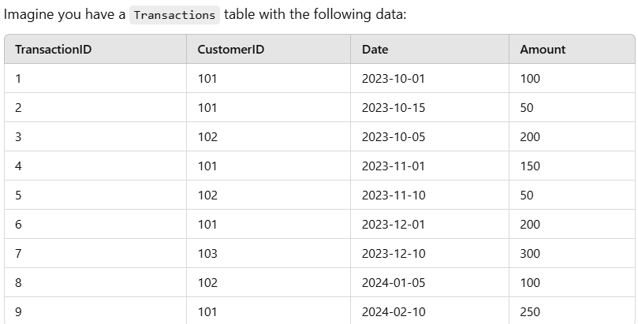

Select

CustomerID,

Date Format(Date,’%Y-%m’) as Month, -- Format the date as Year-Month

SUM(Amount) as Monthly Revenue, -- Monthly revenue per customer

SUM(Sum(Amount)) OVER(Partition by Customer Order BY Rows between UNBOUNDED Preceeding AND Current Row) AS Cumulatice_Revenue

-- Cumulative revenue

FROM Transaction

Where Date >= Date_Sub(Curdate(), Interval 1 Year) -- Filter for the last year

Group by 1,2 -- Group by Customer and Month

Order by 1,2;

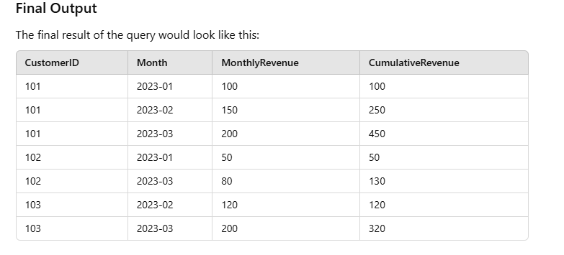

**Que. 7 Using the Employee table (EmpID, ManagerID, JoinDate, Dept, Salary):  
 • Find the nth highest salary.  
 • Identify all employees under a specific manager, including their subordinates at any level.  
 • Find the cumulative salary department-wise for employees who joined in the last 30 days.**

Sol:

* 1. **Find the nth highest salary.**

With CTE AS (

Select Salary, Denserank() OVER(Order by salary desc) as Drnk

FROM Employee)

Select Salary from CTE where Drnk = <N> ;

* 1. **Find the cumulative salary department-wise for employees who joined in the last 30 days**

Select Dept,

SUM(salary) as Cumulative_Salary

FROM Employee

Where Join_Date >= Now() – Interval 30 days

Group by Dept;

OR

`

Select Dept,

SUM(salary) as Cumulative_Salary

FROM Employee

Where DATEDIFF(DAY, Join_Date, GETDATE()) Between 1 And 30

Group by Dept

Order by Join_Date desc;

**Que. 8 Get the second most recent activity, if there is only one activity then return that one.**

create table UserActivity(username varchar(20),activity varchar(20),startDate Date,endDate Date);

insert into UserActivity

values ('Alice','Travel','2020-02-12','2020-02-20') ,

('Alice','Dancing','2020-02-21','2020-02-23'),

('Alice','Travel','2020-02-24','2020-02-28'),

('Bob','Travel','2020-02-11','2020-02-18');

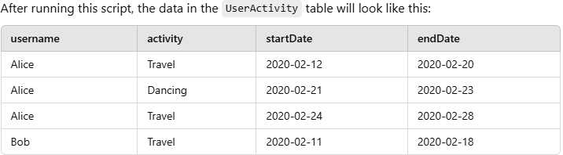

Sol:

With CTE AS (

Select Username,Activity ,

count(*) over (partition by username) as count, ----- Counts total activities per user

Rank() OVER(Partition BY Username Order by StartDate asc) as Rnk ------ Assigns rank based on start date

FROM Useractivity

)

Select Username , Activity from CTE

Where Count = 1 OR Rnk = 2 ------ Selects users with only one activity or the second-ranked activity

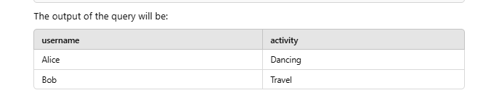

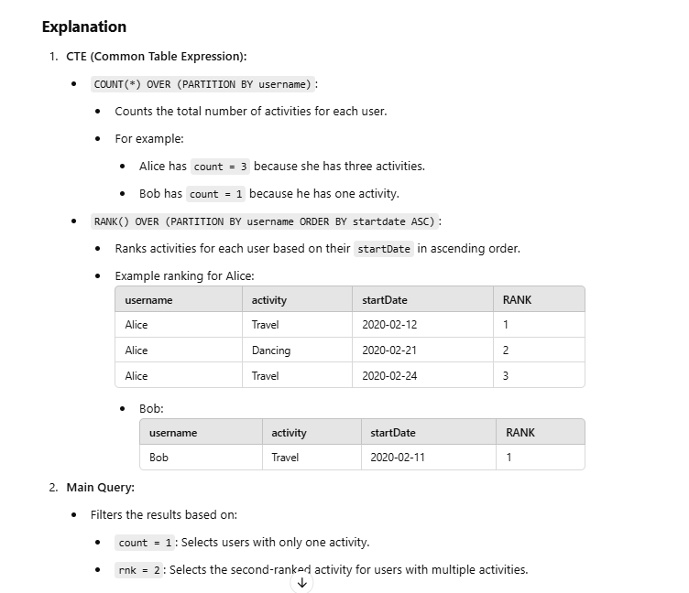

**# Visa Data Analyst Interview Questions:**

# Q. 9 Identify the top 3 areas with the highest customer density.

-- Customer density = (total number of unique customers in the area / area size).

-- Your output should include the area name and its calculated customer density.

SELECT * FROM transaction_records;

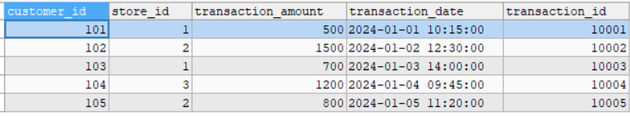

SELECT * FROM stores;

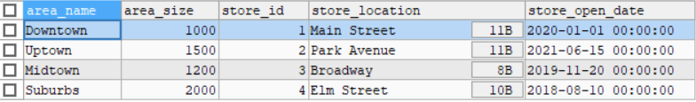

# Sol:

SELECT area_name ,

COUNT(DISTINCT customer_id )/ area_size AS Cust_Density

FROM stores s

JOIN transaction_records t ON s.store_id = t.store_id

GROUP BY area_name ,area_size

ORDER BY 2 DESC Limit 3;

Que. 10 PWC Interview Questions

**a) Write a query to find the cumulative revenue by month for each product category in a sales table.**

Sale_Date | Revenue | Category

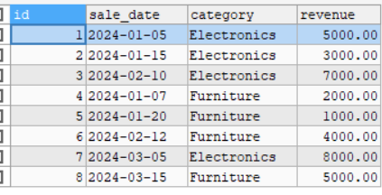

Sol:

WITH Monthly_Revenue AS (

SELECT category,

DATE_FORMAT(sale_date, '%Y-%m' ) AS MONTH,

SUM(revenue) AS Monthly_Rev

FROM sales_pwc

GROUP BY 1,2) ,

Cumulative_Revenue AS(

SELECT category,

MONTH,

Monthly_Rev,

SUM(Monthly_Rev) OVER(PARTITION BY category ORDER BY MONTH) AS Cumulative_Sum

FROM Monthly_Revenue

)

SELECT MONTH , category ,Monthly_Rev ,Cumulative_Sum

FROM Cumulative_Revenue

ORDER BY category, MONTH;

**Que. b) How would you retrieve the top 5 products BY sales volume, excluding ANY products that had zero sales IN the past 3 months?**

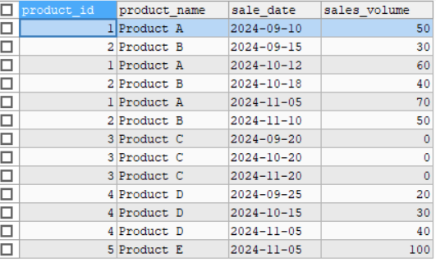

**Sol:**

WITH RecentSales AS (

SELECT

product_id,

product_name,

SUM(sales_volume) AS Total_sal_vol

FROM sales_prod

WHERE sale_date >= DATE_SUB(CURDATE() ,INTERVAL 3 MONTH )

GROUP BY 1,2

HAVING SUM(sales_volume) > 0

),

RankedProducts AS (

SELECT

product_id,

product_name,

Total_sal_vol,

RANK() OVER(ORDER BY Total_sal_vol DESC) AS Rnk

FROM RecentSales

)

SELECT product_id,

product_name,

Total_sal_vol FROM RankedProducts

WHERE Rnk <= 5;